Project Documentation

Implement Client Script & UI Policy (Incident)

1.Introduction
Project Title: Implement Client Script & UI Policy (Incident)

Team ID: SWTID-2026-1195
Team Leader: THIRUMALINI S -
202400700@sigc.edu
Team members
RAJA RAJESHWARI -
202400059@sigc.edu
OVIYA T -
202400526@sigc.edu
SATHIYA PRIYA S -
202400615@sigc.edu

2.Project Overview
Implement Client Script & UI Policy (Incident) is a ServiceNow project focused on customizing and improving the Incident Management form. The project uses UI Policies and Client Scripts to control field behavior, validate user input, and provide dynamic responses based on user actions. The implementation includes creating a UI Policy on the Incident table, configuring a UI Policy Action for the Urgency field, and developing onChange, onSubmit, and onCellEdit Client Scripts. These configurations are tested to ensure that the Incident form works according to the defined requirements. The project helps improve data accuracy, form usability, validation, and user experience while managing incidents ServiceNow.
3. Project Objectives
The main objectives of this project are:
- To create a UI Policy for the Incident table.
- To configure a UI Policy Action for the Urgency field.
- To implement an onChange Client Script.
- To implement an onSubmit Client Script for save validation.
- To implement an onCellEdit Client Script.
- To test all configurations on the Incident form and list.
4. Tools and Technologies
Tool | Purpose
ServiceNow : | Development platform
Incident Table : | Table used for configuration
UI Policy : | Controls field behavior
Client Script : | Performs client-side actions
JavaScript : | Used for Client Scripts
ServiceNow Developer Instance | Development and testing.

5. Software Requirements :
Platform: ServiceNow
Instance: ServiceNow Developer Instance
Table: Incident [incident]
Technology: JavaScript
Features Used:
- UI Policy
- UI Policy Action
- Client Script
- Incident Management
6. System Overview :
The implementation works as follows:
Incident Form
↓
UI Policy
↓
Controls field properties
↓
UI Policy Action – Urgency
At the same time:
Incident Form / List
↓
Client Scripts
↓
- onChange
- onSubmit
- onCellEdit
These configurations control the behavior and validation of Incident records.
7. System Architecture :
The Implement Client Script & UI Policy (Incident) project follows a client-side architecture in the ServiceNow Incident Management module. It controls the behavior of Incident fields based on user actions and predefined conditions. 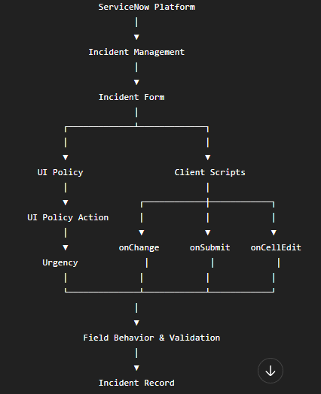

Architecture Components :

1. ServiceNow Platform
Provides the development environment and Incident Management functionality.

2. Incident Management
The Incident table is the main table where incidents are created, updated, and managed.

3. UI Policy
Controls the behavior of fields on the Incident form based on specified conditions.

4. UI Policy Action – Urgency
Controls properties of the Urgency field, such as whether it is mandatory, visible, or read-only.

5. onChange Client Script
Executes when the value of a selected field changes.

6. onSubmit Client Script
Performs validation when the user attempts to save or submit an Incident.

7. onCellEdit Client Script
Handles validation when an Incident field is edited directly from a list view.

8. Incident Record
After successful validation, the Incident record is saved with the required information.

8. Project Implementation

1) Create UI Policy on Incident

Configuration :
Name: High Impact Control
Table: Incident
Active: True
Condition Field: Impact
Operator: is
Condition Value: 1 – High
UI Policy Action Field: Assignment Group
Mandatory: True
Reverse if false: True

Procedure:
Create a UI Policy for the Incident table with the condition Impact = 1 – High. Configure the Assignment Group field as mandatory and enable Reverse if false.
Expected Result:
When Impact is set to High, Assignment Group becomes mandatory.
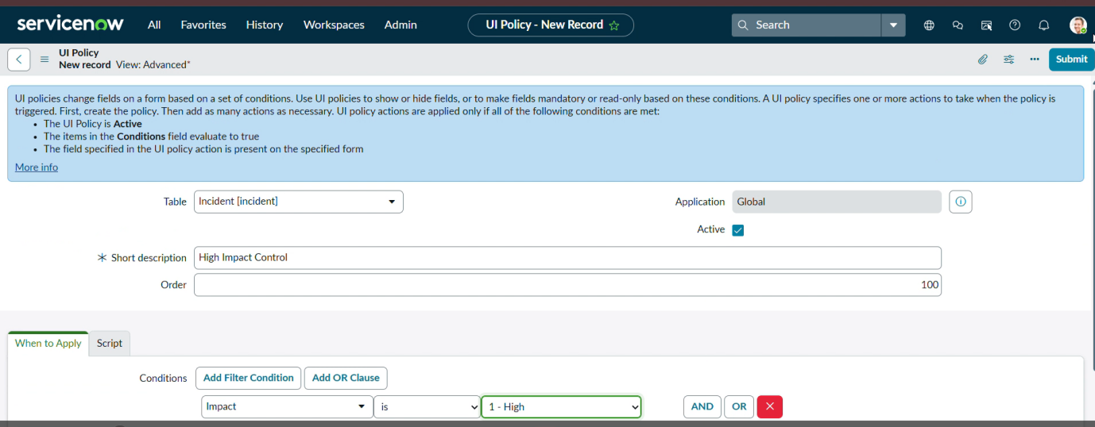
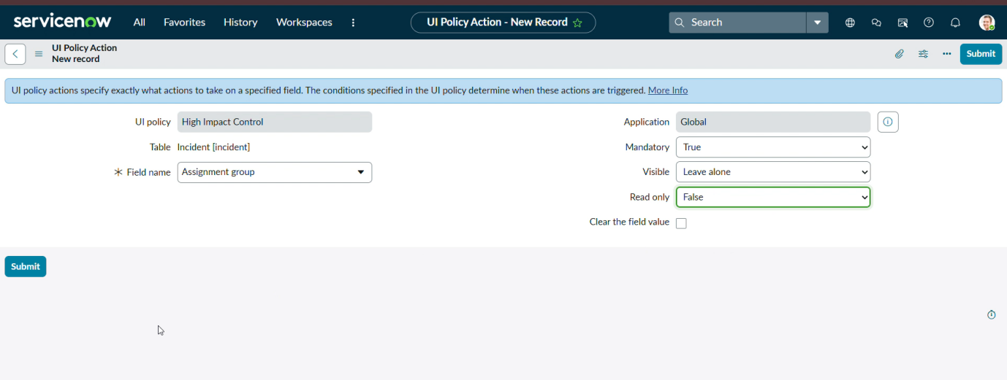
2) Create UI Policy Action – Urgency
Configuration:
UI Policy: High Impact Control
Table: Incident
Field: Urgency
Read-only: True
Visible: True
Procedure:
Open the High Impact Control UI Policy and create a UI Policy Action for the Urgency field. Set Read-only = True and save the action.
Expected Result:
When Impact = 1 – High, the Urgency field becomes read-only.
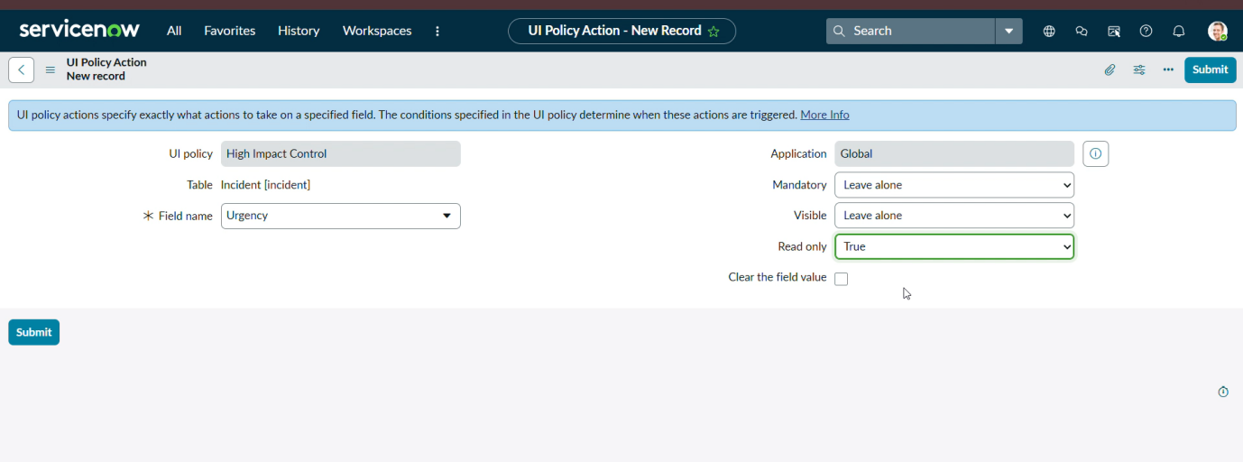
3) Create onChange Client Script
Configuration:
Name: Auto Set Urgency for High Impact
Table: Incident
Type: onChange
Field Name: Impact
Active: True
Condition: Impact = 1 – High
Action: Set Urgency = 1 – High
Script : JavaScript code
Procedure:
Create an onChange Client Script for the Impact field and add the above JavaScript. Save the Client Script.
Expected Result:
When Impact = 1 – High, the Urgency field is automatically set to High.
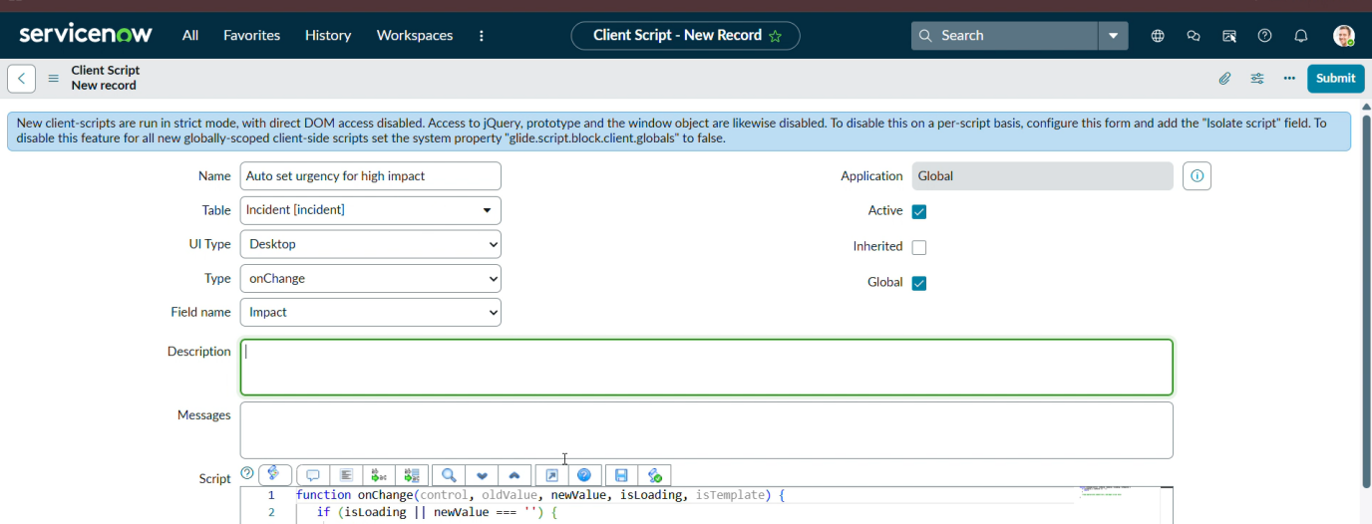
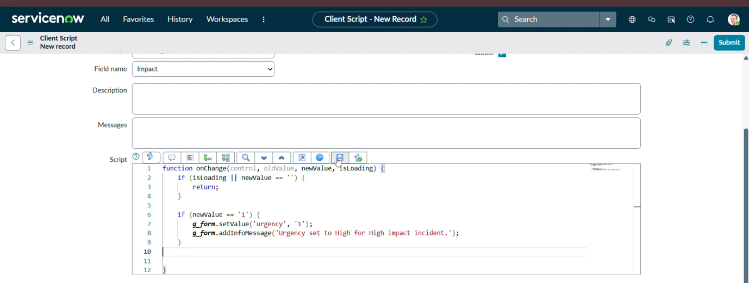
4) Create onSubmit Client Script – Save Validation
Configuration:
Name: Prevent Save if Assigned To Missing
Table: Incident
Type: onSubmit
Active: True
Validation Field: Assigned To
Condition: Assigned To is empty
Script : JavaScript code
Procedure: Create an onSubmit Client Script on the Incident table, add validation for the Assigned To field, enter the JavaScript code, and save the script.
Expected Result:
The Incident record cannot be saved when Assigned To is empty.
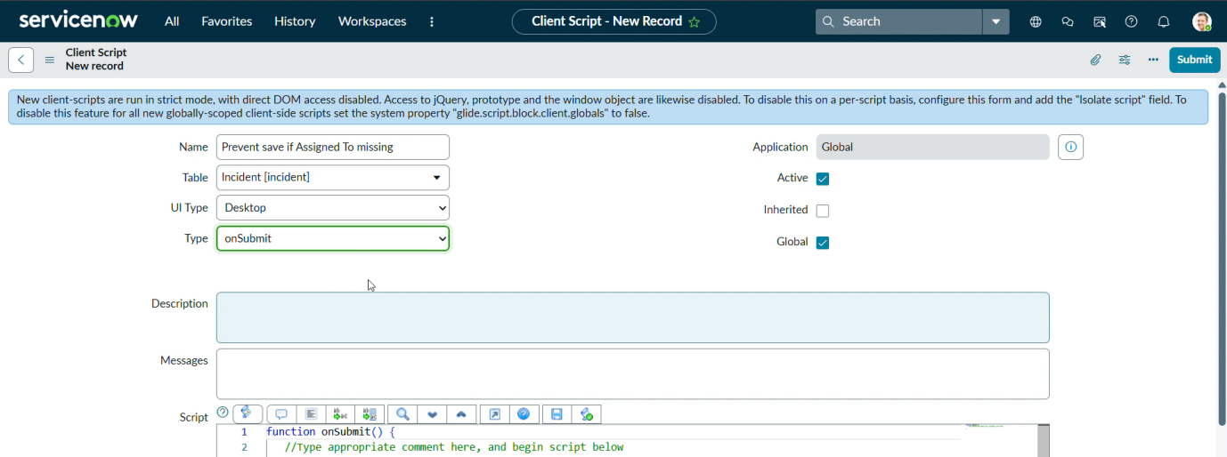
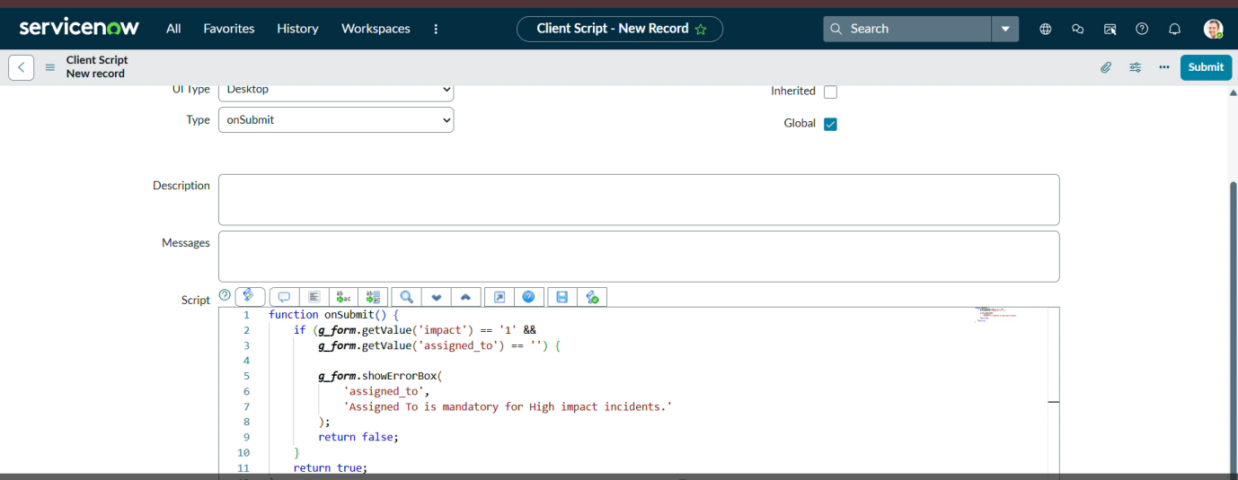
5) Create onCellEdit Client Script
Configuration:
Name: Prevent State Change via List Edit
Table: Incident
Type: onCellEdit
Field Name: State
Active: True
Condition: State is edited from the list
Script : JavaScript code
Procedure: Create an onCellEdit Client Script for the State field, add the validation logic to prevent unauthorized list edits, and save the script.
Expected Result:
Changes to the State field through list editing are prevented when the defined condition is met.
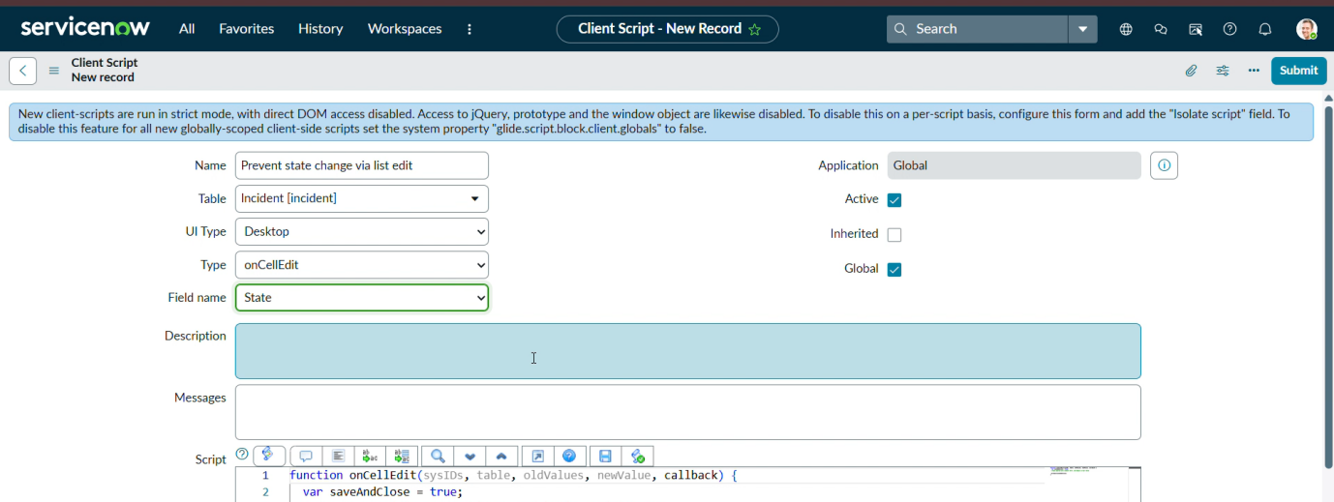
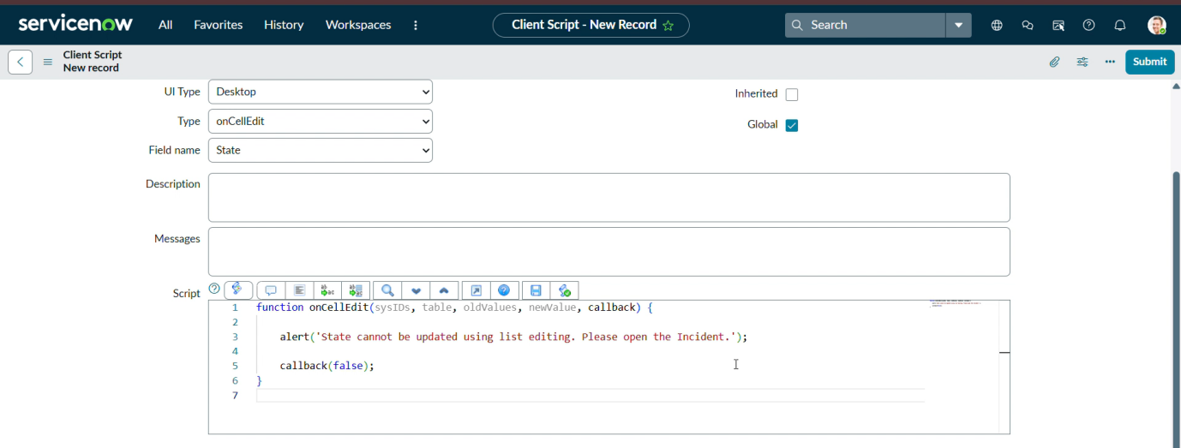
6) Testing the Configuration
1. Mandatory Enforcement
- Set Impact = 1 – High.
- Assignment Group becomes mandatory.
- The Incident cannot be saved without selecting an Assignment Group.
2. Successful Save
- Enter all required Incident details.
- Select Assignment Group and Assigned To.
- The Incident is saved successfully.
3. Reverse Condition Test
- Change Impact from High to another value.
- Assignment Group is no longer mandatory.
- Urgency becomes editable.
4. List Edit Blocking
- Open the Incident list.
- Try to change State directly from the list.
- The onCellEdit Client Script blocks the change.
5. Form-Based Update
- Open an Incident form.
- Change the State field.
- The State can be updated through the form normally.
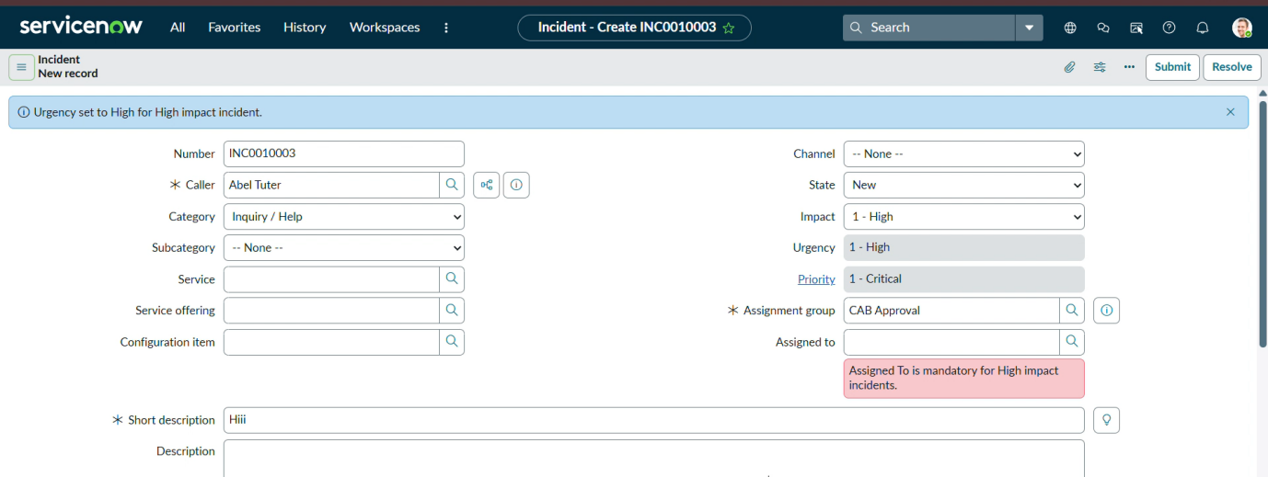
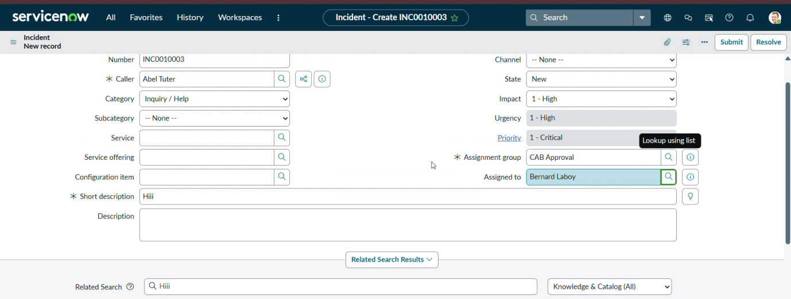

Testing and Validation
The implemented UI Policy, UI Policy Action, and Client Scripts were tested on the ServiceNow Incident table to verify their functionality. The tests covered mandatory field enforcement, automatic urgency updates, save validation, reverse conditions, list editing restrictions, and form-based updates. The configurations were checked under different Incident conditions to ensure that the expected behavior was applied correctly.

Conclusion
The Implement Client Script & UI Policy (Incident) project successfully demonstrates how ServiceNow can be customized using UI Policies and Client Scripts. The implementation provides dynamic field behavior, automatic updates, validation during record submission, and control over list editing. These configurations help improve data accuracy, consistency, and usability in Incident Management.

Demo link:
https://drive.google.com/file/d/1tzEVRnQvsnpj-Ag-rY4PHJMu7MGAe7iE/view?usp=drivesdk
GitHub link:

